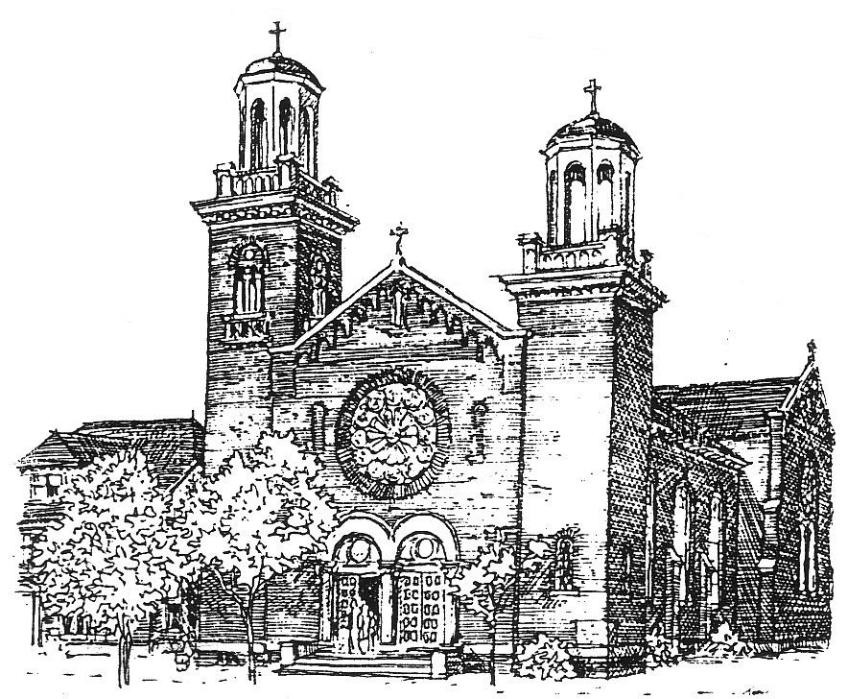

**535 8th Street East**

**Saskatoon, Saskatchewan**

**S7H 0P9**

SAINT JOSEPH’S PARISH

[www.stjosephsaskatoon.ca](http://www.stjosephsaskatoon.ca/)

Phone: 244-1556 Fax: 242-8916 E-mail: stjosephparish@sasktel.net

**Registration for Sacramental Prep - CONFIRMATION**

Year: 20…… - 20…….

**Please indicate the numbers of people attending the celebration from your family: ..........**

🙞✞🙜

[Please print clearly]

Child's name: __________________________________________________

First name Middle Surname

Age: _____________________ Date of Birth: ________________

School: ___________________________________ Grade:__________________

Mother's name: __________________________ ___ Religious Denomination:

First name Maiden name

Father's name:__________________________________ Religious Denomination:

First name Surname

Address:___________________________________________________ Postal Code:_________________

Phone: H:____________________W:______________________C:_______________________

Email:_______________________________________

Child's Parish of Baptism:___________________________ City/Province:_______________________

Date of Baptism (DD/MMM/YYY):_________________________________

Are you registered at St. Joseph Parish Saskatoon? Yes______ No__________

If no, present parish:____________________________________________________________________

A copy of your child's Baptism certificate is required at the first class.

Fees for materials can also be paid at the first class.

***************************************************************************************

Office use only:

Baptism cert recd____________ Fee paid (cheque or cash) _________ Book received_____